Day 20 - 23th july 2025

Name :Aravind Kasanagottu

ID:mvsnarav  
  
  
Task 1:

Wap to create a class Student.. With 3 methods

registrationDetails(), marksCalc(), feesCalc().

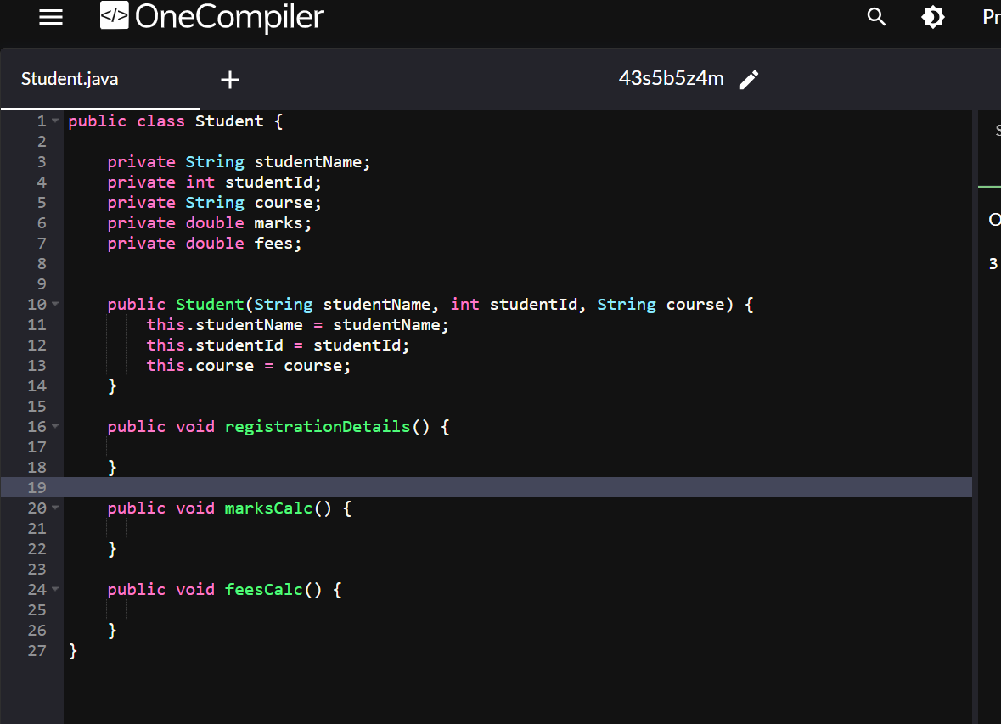

Task 02:

class Employee {

    private String name;

    private String email;

    private double salary;

    // Methods related to employee data

    // Method to generate PDF report

    public void generatePdfReport() {

        // Code to generate PDF report

    }

    // Method to send email

    public void sendEmail() {

        // Code to send email

    }

}

In the above example code, the Employee class violates the SRP because it has multiple responsibilities: managing employee data, generating PDF reports, and sending emails. These responsibilities are not cohesive and may change for different reasons.

Implementing SRP:

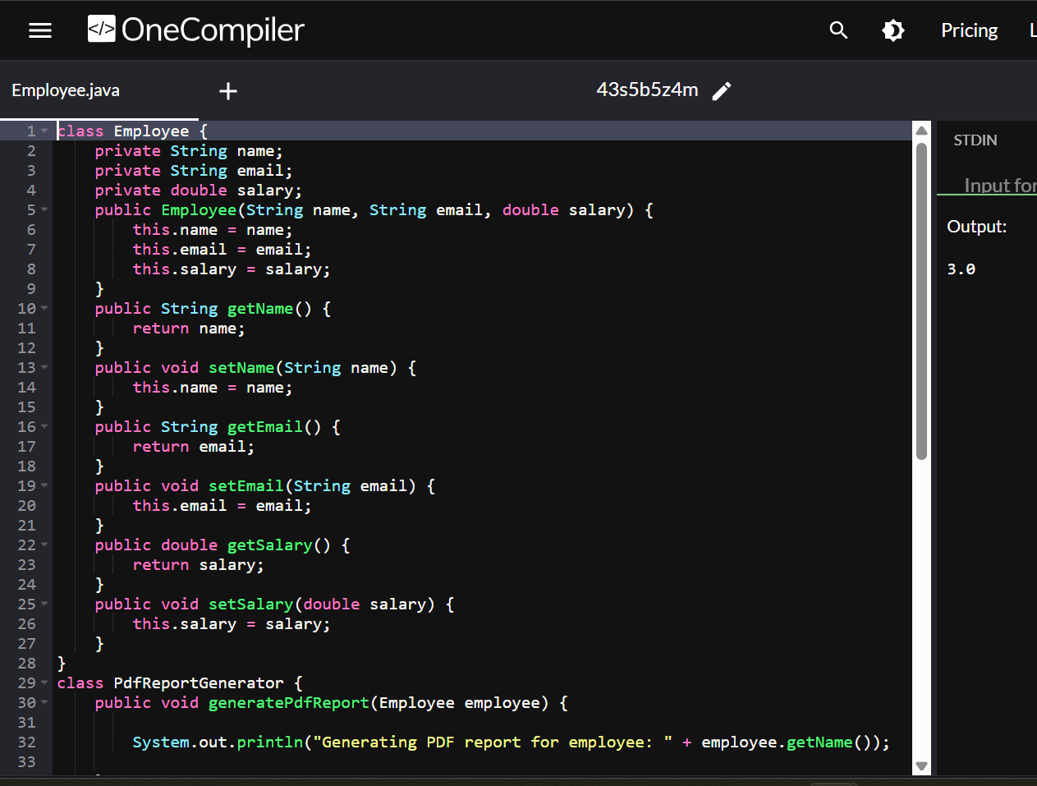

Task 03:

/*

In the below example, the `PaymentProcessor` class violates the OCP because every time a new payment type needs to be supported, the `processPayment` method needs to be modified, which is against the principle of being closed for modification.

*/

class PaymentProcessor {

    public void processPayment(String paymentType, double amount) {

        if (paymentType.equals("credit card")) {

            // Process credit card payment

} else if (paymentType.equals("paypal")) {

// Process PayPal payment

} else if (paymentType.equals("bitcoin")) {

// Process Bitcoin payment

}

// ... more payment types

}

}

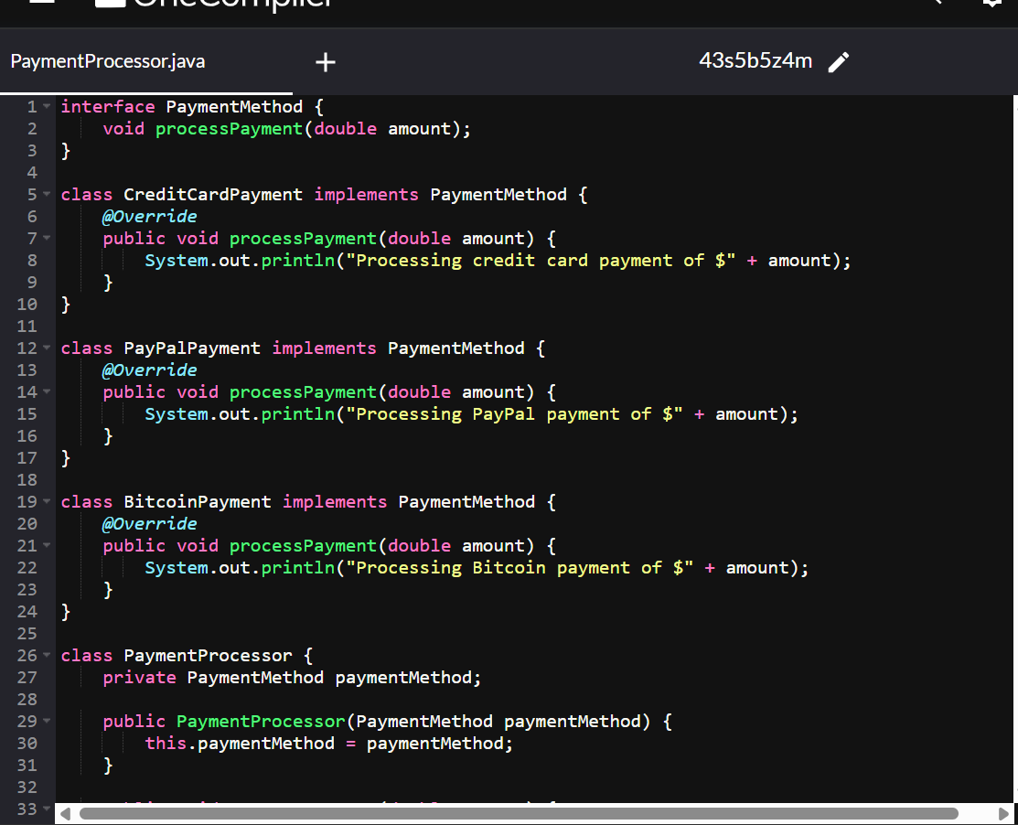

Task04:

Sequence diagram:

@startuml

    Prasunamba -> Atlas_Batch1: Congratulations all

    Atlas_Batch1 --> Prasunamba: Thank you Meher

     Prasunamba -> Atlas_Batch1: Good luck for your Module 3

    Atlas_Batch1 --> Prasunamba: Thank you Meher in advance

or

    Prasunamba < -- Atlas_Batch1: Thank you Meher in advance

@enduml

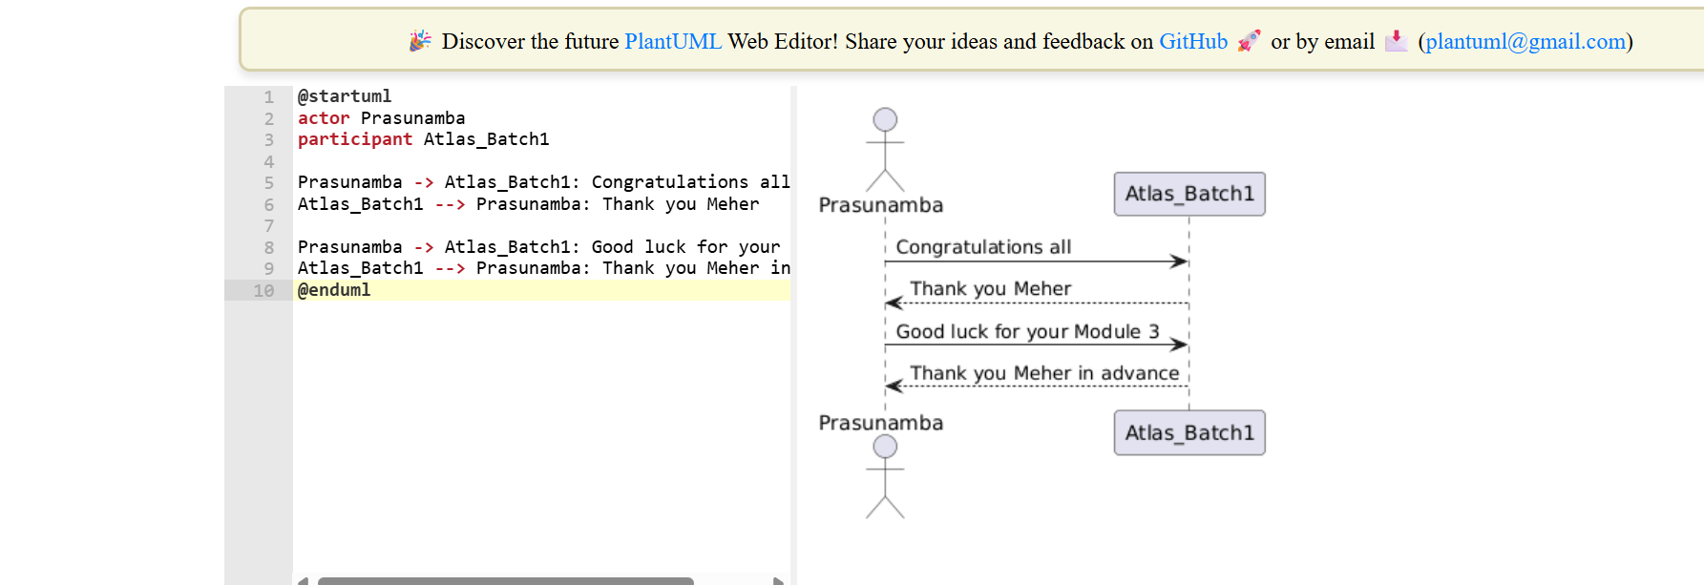

Task 5:

@startuml

    pax "A" as A

    pax "B" as B

    A --> B: Message/action

    A ..> B: reply

@enduml

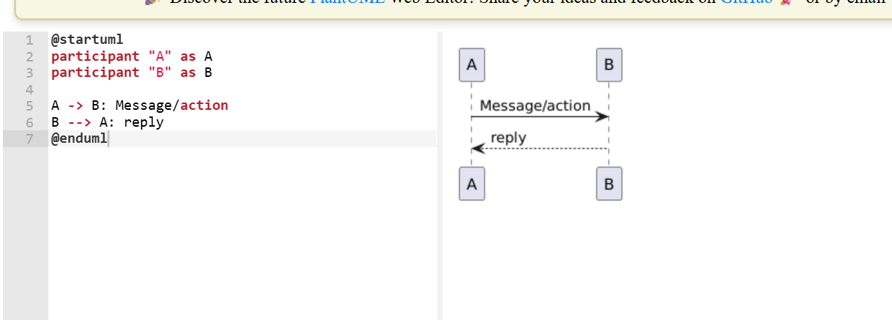

@startuml

class Car

Driver - Car : drives >

Car *- Wheels : have 4 >

Car -- Person : < owns

@enduml

